Ideation Phase
Empathize & Discover

Date | 16 February 2026
Team ID | LTVIP2026TMIDS73212
Project Name | ResolveNow - Online Complaint Registration and Management System
Maximum Marks | 4 Marks

Empathy Map Canvas:
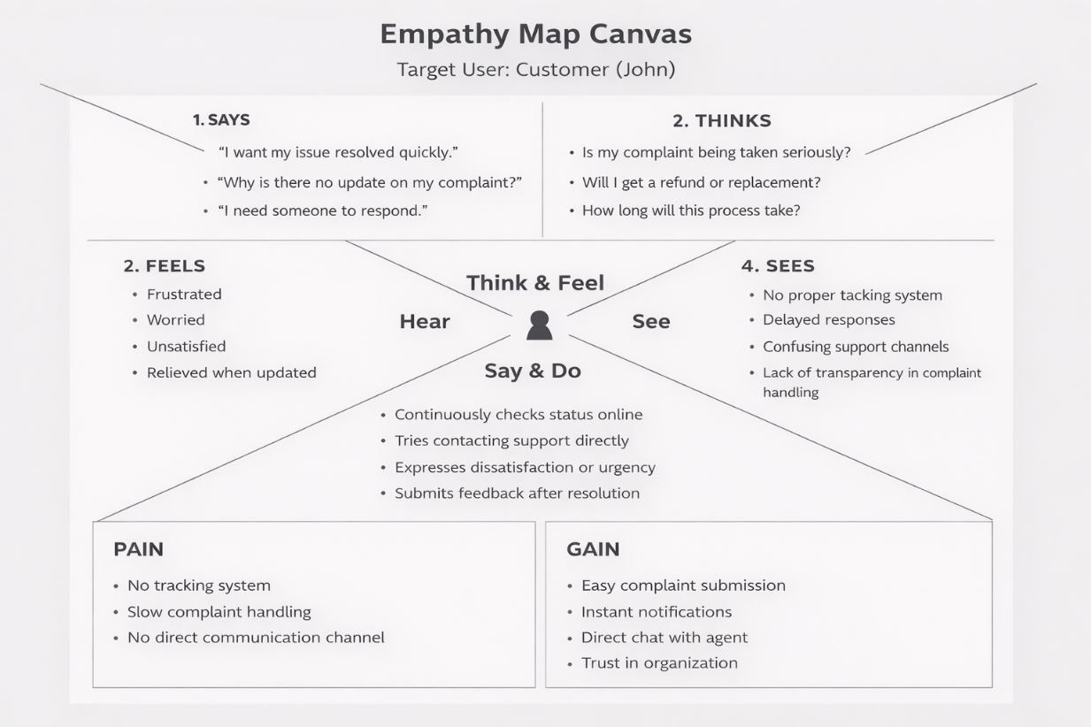

Target User: Customer (John)

Says
- “I want my issue resolved quickly.”
- “Why is there no update on my complaint?”
- “I need someone to respond.”

Thinks
- “Is my complaint being taken seriously?”
- “Will I get a refund or replacement?”
- “How long will this take?”

Feels
- Frustrated
- Worried
- Unsatisfied
- Relieved when updated

Sees
- No proper tracking system
- Delayed responses
- Confusing support channels

Hears
- “Please wait for 48 hours.”
- “We will get back to you.”
- “Your complaint is under review.”

Needs
- Transparent complaint tracking
- Real-time updates
- Quick resolution
- Secure communication

Pain Points
- No tracking system
- Slow complaint handling
- No direct communication channel

Gains
- Easy complaint submission
- Instant notifications
- Direct chat with agent
- Trust in organization

